**OIM12c Uninstallation**

AS per OIM12c having the quick uninstallation process which is in three steps as follow

1. OIM Quick start uninstallation
2. OUD uninstallation
3. Weblogic Server uninstallation

After these steps must delete Oracle_Home which contain all the sub folders for complete removal.

**OIM Uninstall**

1. Before running the uninstallation check Oracle_Home is attached with central inventory

If no attachement Oracle_Home to Central Inventory error find while running the script of deinstall.sh

1. To the sorting the same set the path

cd /apps/Platform/Middleware/Oracle_Home/oui/bin

./attachhome.sh

After running the script will get success page

1. Then run deinstallation

cd /apps/Platform/Middleware/Oracle_Home/oui/bin

./deinstall.sh

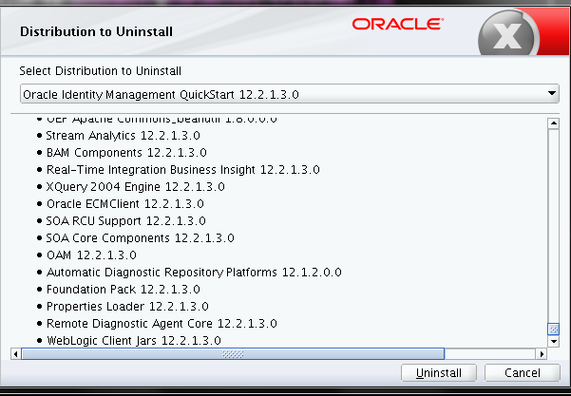

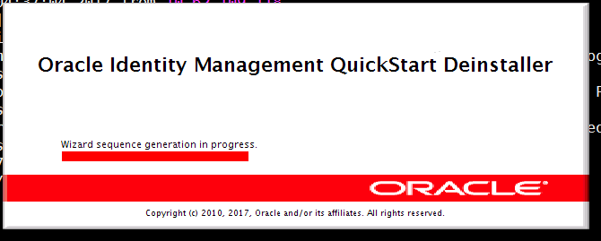

1. Will get welcome page Next

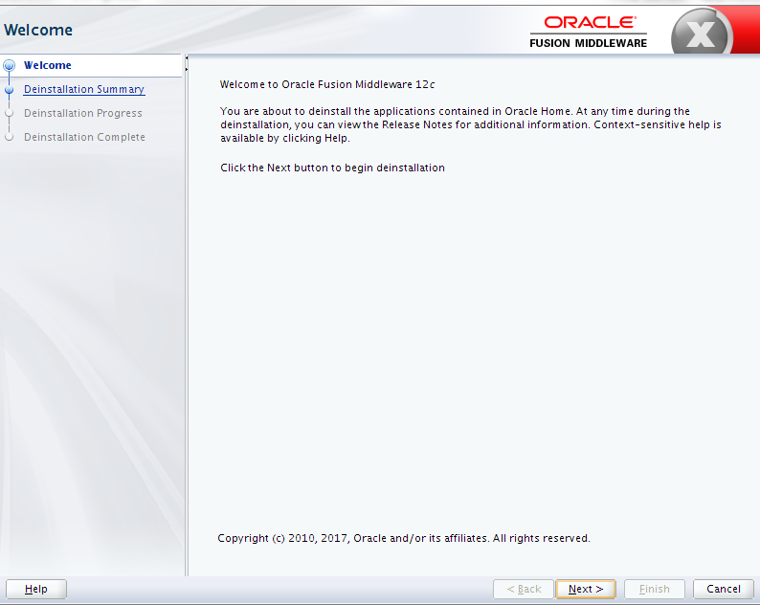

1. Then click Deinstall

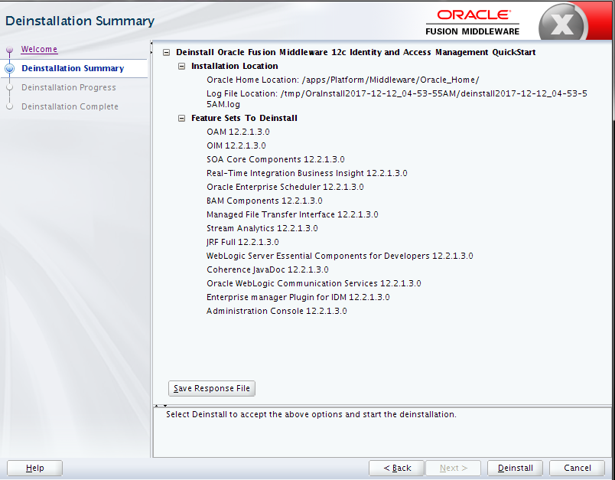

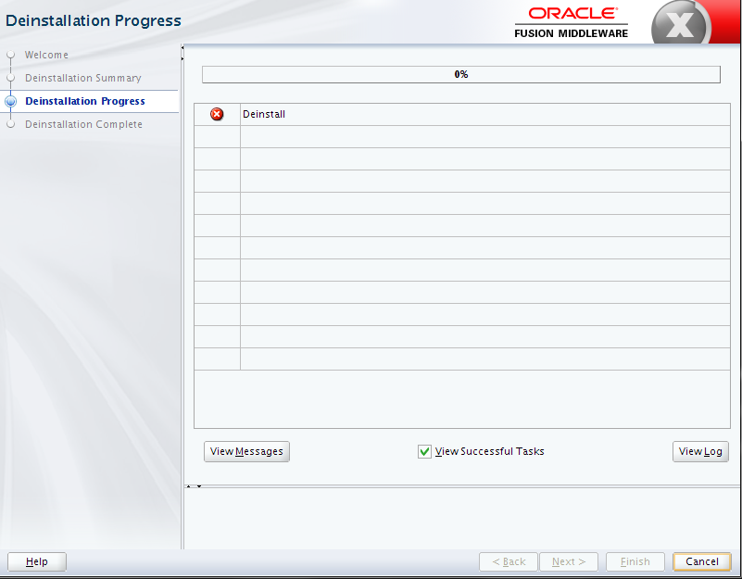

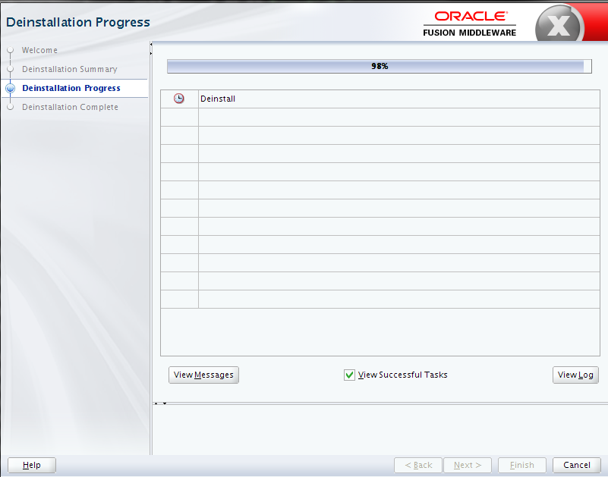

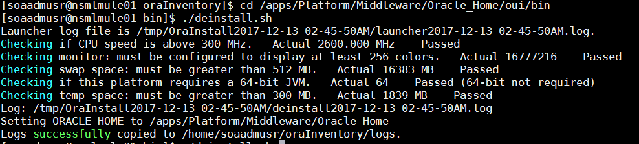

1. Then click on finish.

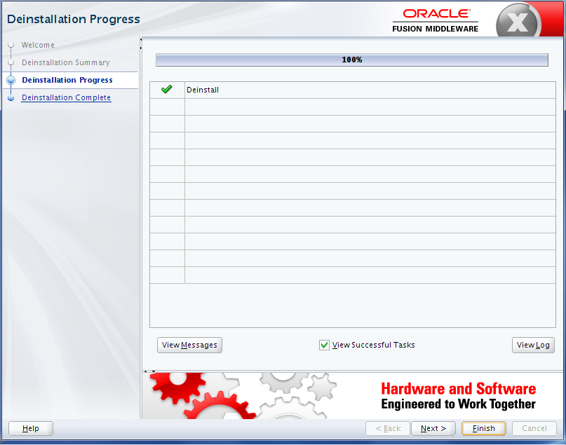

**OUD Uninstallation**

Go to the path select OUD and run deinstallation

cd /apps/Platform/Middleware/Oracle_Home/oui/bin

./deinstall.sh

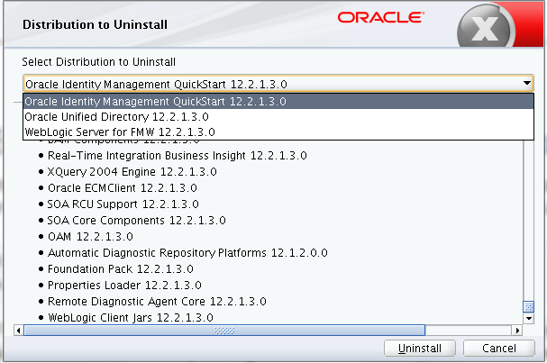

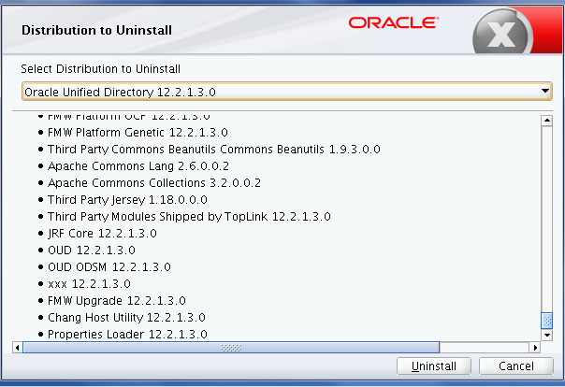

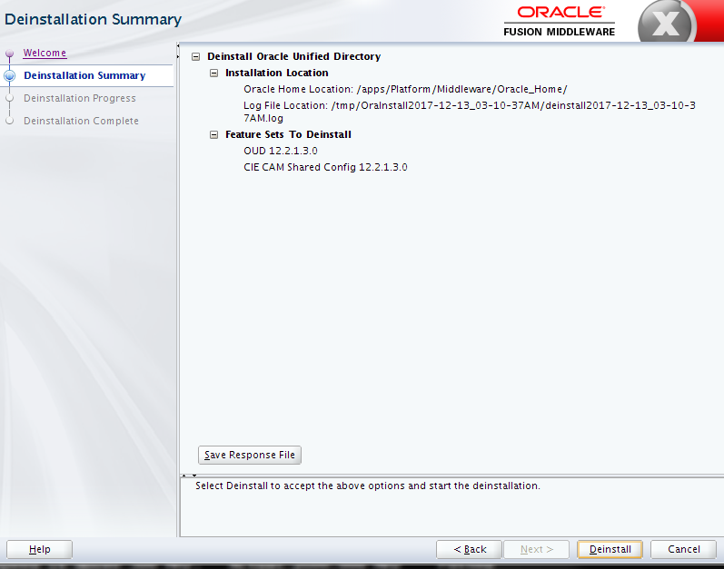

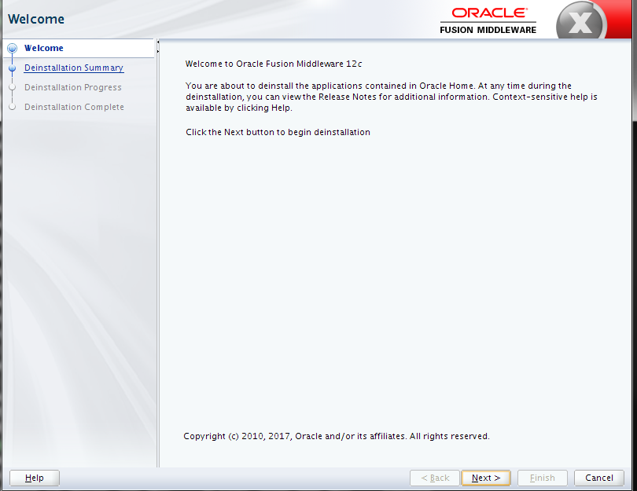

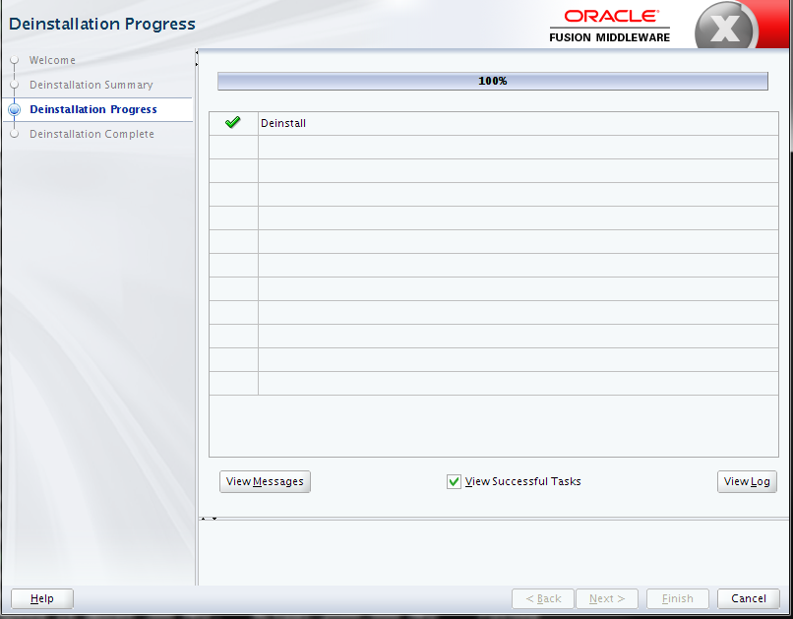

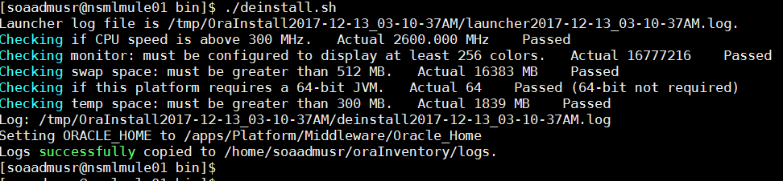

**WebLogic server 12c Uninstallation**

Go to the path select Weblogic and run deinstallation

cd /apps/Platform/Middleware/Oracle_Home/oui/bin

./deinstall.sh



